CPSC 4317: Computer Networks
Assignment 4
Due 10:00am, Oct. 25, 2024 (Friday)

Name: ____Andrew Kalathra____

LUID: _____L20498001________

Date: ____10/25/2024________

Textbook:
18.15 (10 points) (when a packet switch receives a distance-vector message from a neighbor, will the switch’s forwarding table always change? Explain)

- No, the forwarding table for the switch will not ALWAYS change as on some occasions, the shortest path and next hop will stay the same according to the distance vector message received.

18.16 (10 points) (what is a routing loop?)
- To understand a routing, we must first discuss next hop. Much like a linked list, each node points to another node in reference to a final destination node (based on the switch’s forwarding table), and these are called next hops.
- If the next hops in a series of nodes point back to each other in an infinite loop, this is referred to as a routing loop. These are not good as packets will never be delivered.

Textbook:
21.11 (15 points) (Is the CIDR prefix 1.2.3.4/29 valid? Why or why not?)
- I do not see why this would not work. Each number is valid, and the mask also is valid.
 | 1 | 2 | 3 | 4
CIDR | 00000001 | 00000010 | 00000011 | 00000100
29 bit mask | 11111111 | 11111111 | 11111111 | 11111000
- In this, we can see that the last 3 bits are reserved for the host to modify, so yes, this is a valid CIDR prefix.
Textbook:
21.12 (15 points) (Suppose you are an ISP with a /24 IPv4 address block. Explain whether you can accommodate a request from a customer who needs addresses for 255 computers. Hint: consider the special addresses)
- For 255 computers, we need 8 bits (2⁸ = 256)
- Using IPv4, we have 32 bits at our disposal. However, using a /24 mask, we can see that we only have 32 – 24 = 8 bits left.
- Luckily, we have these 8 bits, which is exactly what we need...except that we forgot a crucial step
- When taking those last 8 bits into account, 2 specific sequences cannot be used, namely: 00000000 and 11111111
- So now we have 2⁸ – 2 = 254 sequences, which is less, so no, we cannot have a /24 mask and accommodate 255 differently address computers.

Programming question:

Please use the following network topology to implement the Dijkstra’s algorithm (Algorithm 18.2 in the textbook) to find the shortest path from source node A to all other nodes.

You may use either Java or C/C++ language. You can hardcode the network topology into your program.

(50 points)

A
E
D
C
B
F
2
2
1
3
1
1
2
5
3
5

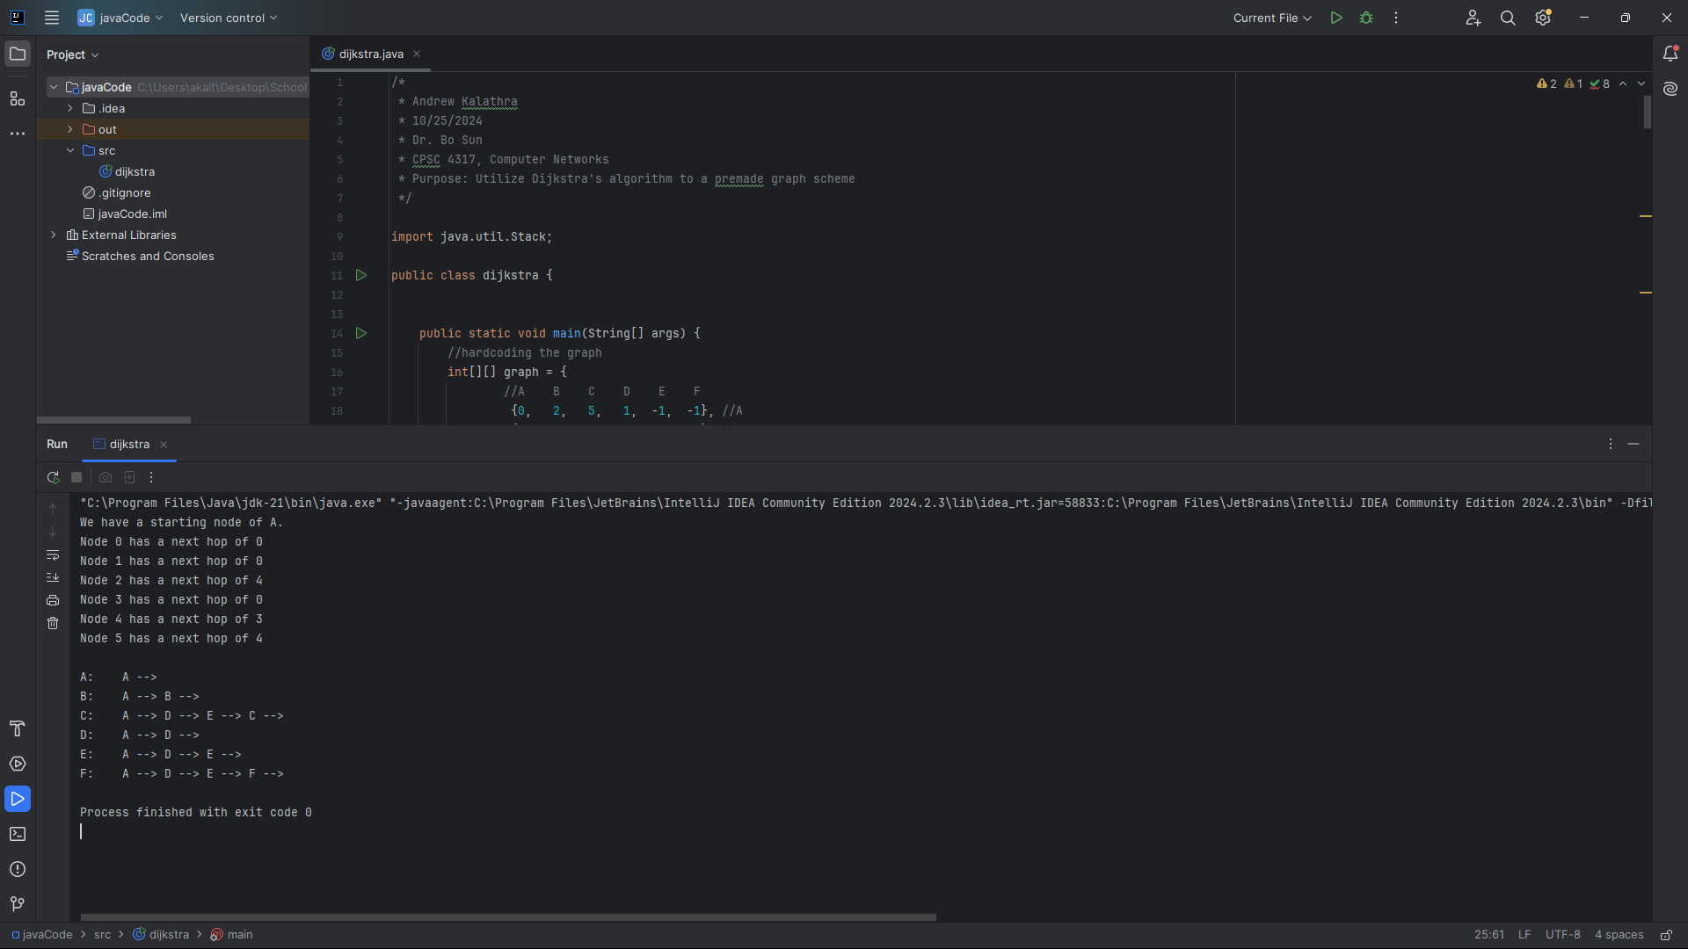
Turn in:

Only softcopy is required.
- Please use the blackboard system to turn in the softcopy of all your solutions.
F
F

